CL Tutorial 10 - Cosmo Bobak

# Exercise 2

fromNFAtoDFA differs from fromFSMtoDFA in that it runs (eClose es ss) to produce ss’, where fromFSMtoDFA just runs singleton.

# Exercise 4

I have no idea how to do this.

# Exercise 5

I have no idea how to do this.

# Exercise 10

1. NFA: 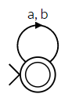 DFA: 
2. NFA: 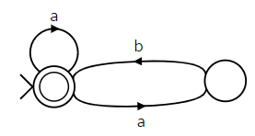DFA: 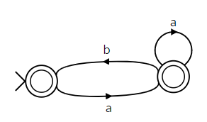
3. NFA: DFA: 